密云区高三年级阶段测试
英语试卷 2017年9月
考试时间：120分钟

第一部分：听力理解（共三节，30分）
第一节（共5小题；每小题1.5分，共7.5分）
听下面5段对话。每段对话后有一道小题，从每题所给的A、B、C三个选项中选出最佳选项。听完每段对话后，你将有10秒钟的时间来回答有关小题和阅读下一小题。每段对话你将听一遍。
1. Where are the speakers?
A. At a bank. B. At a hotel. C. At an airport.
2. What’s the relationship between the two speakers?
A. Neighbors. B. Roommates. C. Friends.
3. What does the man want to buy？
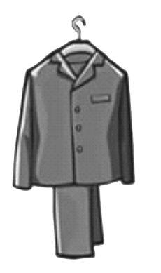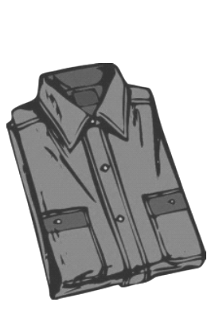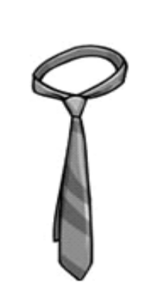
A. B. C.
4. What was the man fined for?
A. Wrong parking. B. Running a red light. C. Driving too fast.
5. When does the flight leave?
A. At 8:30 am. B. At 9:00 am. C. At 9:30 am.
第二节（共10小题；每小题1.5分，共15分）
听下面4段对话。每段对话后有几道小题，从每题所给的A、B、C三个选项中选出最佳选项。听每段对话前，你将有5秒钟的时间阅读每小题。听完后，每小题将给出5秒钟的作答时间。每段对话你将听两遍。
听第6段材料，回答第6至7题。
6. How is the woman trying to lose weight now?
A. By eating every other day.
B. By drinking plenty of water.
C. By eating orange-colored foods.
7. What does the man think of the woman’s diets?
A. Ridiculous. B. Balanced. C. Effective.
听第7段材料，回答第8至9题。
8. What is the girl doing?
A. Doing her homework. B. Practicing the guitar. C. Making some records.
9. What does the girl think of working in a bank？
A. Boring. B. Important. C. Well-paid.
听第8段材料，回答第10至12题。
10. Where will they have a snack?
A. Outside the church. B. On the hill top. C. At the car park.
11. Where is the old church?
A. Near the waterfall. B. At the foot of the hill. C. Behind the park.
12. How long will they spend on the hiking?
A. 2 hours. B. 3 hours. C. 4 hours.
听第9段材料，回答第13至15题。
13. What is the grand prize for the winner?
A. Some cash and a trip. B. A set of books. C. A set of DVDs.
14. How many muscles does a cat have in each ear?
A. 32. B. 33. C. 34.
15. What animal is the largest on the earth?
A. A shark. B. An elephant. C. A blue whale.
第三节（共5小题；每小题1.5分，共7.5分）
听下面一段对话，完成第16至20题，每小题仅填写一个词。听对话前，你将有20秒钟的时间阅读试题，听完后你将有60秒钟的作答时间。这段对话你将听两遍。
Car Rental Form
Customer information | Name: Ronald 16  Age: 33  Driving license type: 17
Car information | Car type: A Toyota  Time: From next 18 to Thursday  Total rent: £ 19 , not including petrol
Pick-up time | Around 20
第二部分：知识运用（共两节，45分）
第一节：单项选择（共15小题；每小题1分，共15分）
从A、B、C、D四个选项中，选出可以填入空白处的最佳选项。
21. I live next door to a couple ______ children often make a lot of noise.
A. whose B. why C. where D. which
22. — Jeff, what’s up? You are not yourself today.
— Oh, mom. I really wish I ______ the chance but I failed.
A. had got B. would get C. will get D. got
23. I think _____ impresses me about his painting is the colors he uses.
A. what B.that C. which D. who
24. _____ in the poorest area, he had a long, hard road to becoming a football star.
A. Being raised B. Raising C.Raised D. To raise
25. I didn’t know your mobile phone number; otherwise I ______ you the moment I got to Canada.
A. would ring B. would have rung C. had rung D. rang
26. The pianist ______ a love for music when he was a little boy.
A. was developed B. developed C. had developed D. has developed
27. The producer comes regularly to collect the cameras _____ to our shop for quality problems.
A. returning B. returned C. to return D.to be returned
28. Listening to music at home is one thing, going to hear it _____ live is quite another.
A. perform B. performing C. to perform D. being performed
29. — Can I come over in an hour?
— Sorry, I _______ the house.
A. will clean B. am cleaning C. clean D. will be cleaning
30. _____ the past year as an exchange student in Hong Kong, Linda appears more mature than those of her age.
A. Spending B. Spent C. Having spent D. To spend
31. If I ______ the project earlier, I would be enjoying myself on the beach now.
A. might finish B. finished C. had finished D. would have finished
32. I know little about the accident because not much ______ about it up to now.
A. has said B. has been said C. had said D. had been said
33. Remember me to your parents when you _______ them.
A. are calling B. call C. will call D. have called
34. _____ the forest park is far away, a lot of tourists visit it every year.
A. As B. When C. Even though D. In case
35. The church tower which _____ will be open to tourists soon. The work is almost finished.
A. has restored B. has been restored C. is restoring D. is being restored
第二节：完形填空（共20小题；每小题1.5分，共30分）
阅读下面短文，从短文后各题所给的四个选项（A、B、C和D）中，选出可以填入空白处的最佳选项。
Music to My Ears
Robby was 10 for his first piano lesson in my class. Much as he tried, he __36__ even the basic rhythm. However, he dutifully reviewed the pieces that I required.
Over the months he tried and tried while I __37__ and encouraged him. At the end of each lesson he'd always say, "My mom's going to hear me play some day." __38__ it seemed hopeless.
I only knew his mother from a __39__as she waited in her aged car to pick him up. Then one day Robby stopped coming. I was secretly __40__ that he stopped because of his lack of ability.
Weeks later I informed the students, including Robby, of the coming recital（独奏）. To my __41__, Robby asked me if he could be included. I told him he really did not qualify because he had __42__ out. He said his mom had been sick and unable to take him to lessons but he was still __43__ .
“I've just got to play!" he __44__. Something inside me let me allow him to. [来源:Z§xx§k.Com]
Then came the recital night. The gym was __45__ with parents. I put Robby up __46__, thinking that I could save his poor performance through my “curtain closer（谢幕）.”
The recital went off smoothly. Then Robby came up on stage. His clothes were wrinkled and his hair was __47__. "Why didn't his mother at least make him comb his hair for this special night?" I thought.
Robby pulled out the piano bench and began. I was not __48__ for what I heard next. His fingers were __49__ on the keys. Never had I heard Mozart played so well by people of his age. After he ended, everyone was __50__ their feet in wild applause.
In __51__ I ran up on stage and put my arms around Robby. "I've never heard you play like that, Robby! How did you __52__ it?"
Robby explained, "Well, Miss Hondorf…remember I told you my mom was sick? …__53__ she had cancer and passed away yesterday. She was born deaf, so tonight she could hear me play in heaven. I wanted to make it special." [来源:学科网ZXXK]
There wasn’t a __54__ eye in the house. That night I felt he was the teacher and I was the pupil, for it was he who taught me the meaning of perseverance and __55__.
36. A. lacked B. had C. showed D. got
37. A. listened B. learned C. checked D. played
38. A. And B. But C. So D. Or
39. A. conversation B. performance C. distance D. picture
40. A. guilty B. sad C. anxious D. glad
41. A. relief B. surprise C. pleasure D. satisfaction
42. A. stepped B. worn C. run D. dropped
43. A. acting B. performing C. practicing D. recording
44. A. insisted B. suggested C. complained D. threatened
45. A. lined B. packed C. piled D. covered
46. A. least B. most C. first D. last
47. A. messy B. cool C. neat D. dull
48. A. eager B. concerned C. prepared D. grateful
49. A. hesitating B. dancing C. touching D. crawling
50. A. over B. under C. in D. on
51. A. chaos B. tears C. silence D. return
52. A. find B. feel C. make D. like
53. A. Gradually B. Suddenly C. Frequently D. Actually
54. A. dry B. curious C. bright D. wet
55. A. regret B. talent C. love D. courage
第三部分：阅读理解（共两节，40分）
第一节（共15小题；每小题2分，共30分）
阅读下面短文，从每题所给的四个选项（A、B、C和D）中，选出最佳选项。
A
Proper Care and Use of a Microscope
A microscope is a useful instrument for observing small objects. It shows people the details that are undetectable when they observe with their own eyes. Before using the microscope, please read the instruction below.
Caution:
Microscopes are both delicate and expensive, and must be handled with care.
1. Always carry the microscope with two hands—one supporting the base and the other on the arm.
2. Keep the stage clean and always use a glass slide for specimens, the things tested or examined.
3. To avoid pressing the glass slide when focusing, begin with the lens (镜头) close to the specimen and gradually back off to focus.
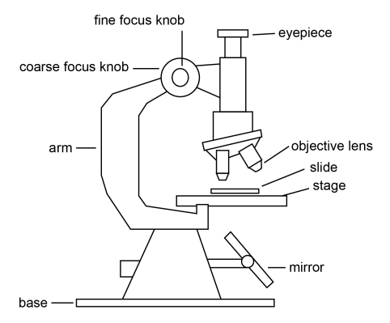
4. Keep the microscope covered to prevent the buildup of
dust while it is being stored.
How to Use the Microscope:
1. Plug in the lamp.
2. Place a specimen on a slide.
3. Adjust the mirror so it reflects light from the room up into the objective lens.
4. Place your slide with the specimen directly over the center of the glass circle on the stage. If it is a wet slide, be sure the bottom of the slide is dry.
5. With the LOW POWER objective lens placed over the slide, use the coarse focus knob to lower the lens to the lowest point.
6. Look through the eyepiece with one eye while closing the other eye. Slowly raise the lens until the focus is relatively clear.
7. Use the fine focus knob to make very small changes to the focus.
8. Without changing the focus knobs, switch to the HIGH POWER objective lens. Once you have
switched to HIGH POWER, use only the fine focus knob to make the image sharper.

56. When using a microscope, you should use a glass slide for specimens to ______.
A. keep the stage clean
B. avoid pressing the lens
C. prevent the buildup of dust
D. support the base and the arm
57. When observing onion cells on a slide, which of the following should you do first?
A. Lower the lens.
B. Adjust the mirror.
C. Turn the fine focus knob.
D. Look through the eyepiece.
58. What is the main purpose of this passage?
A. To show the reader the various parts of a microscope.
B. To persuade the reader to buy this type of microscope.
C. To instruct the reader how to use a microscope with care.
D. To show the reader some advantages of using a microscope.

B
Gift Idea

The other day I was shopping for Grandma when I realized I had no gift ideas at all. It was not a birthday gift or anything like that. It was simply sort of a hello gift. That is how we do things in my family. We don’t really give gifts for special occasions. Instead, we occasionally just give presents to each other to tell other people that we are thinking about them.
That was why I wanted a gift for Grandma. But it was like my imagination had dried up. I have gone through all of the gift ideas in previous years, fruits, wines, cheeses, little handmade crafts, and anything else that you can give to a grandmother. I had even given her gift watches, and CDs. What else was there?
I have always found gift ideas for men a little bit easier than for women, because for men, you can always get the usual things, such as video games, power tools and things like that. With a woman’s gift idea, however, you have to know more about her. You cannot just get someone a book or a CD. You have to know all about her taste in movies, music, and literature.
My grandmother likes to read a lot, but what she likes is always pretty popular. I didn’t want to get her a book that she might not like, but I was running out of time. I needed a gift idea for this weekend and went to visit her. After all, I hadn’t seen her for a long time. I wanted to give her a gift so she would not feel ignored.
Finally, I came up with the perfect gift idea. I made a collection of all the stories I had written in the past year. It wasn’t a typical gift idea like a bunch of flowers, but it really worked in the situation. You see, I am a writer and my grandma has always been my fan. Anyway, I had been learning about bookbinding recently, and had pretty much mastered the art. I figured that I would add a little bit of handmade artwork to the stories, bind it altogether, and give it to her. It took hours to complete, but it was well worth the effort. She absolutely loved it.
59. The writer chose a gift for Grandma to _____.
A. celebrate a special family occasion
B. please her during a weekend visit
C. congratulate her on her birthday
D. beg her pardon for ignoring her
60. What gift did the writer finally decide to give his grandma?
A. Gift watches. B. A bunch of flowers.
C. Artwork made by hand. D. Stories written by himself.
61. What does the writer feel about giving gifts to women?
A. Interesting. B. Challenging. C. Time-wasting. D. Popular.
62. We can learn from the passage that _____.
A. the writer is a successful novelist
B. most people are particular about gifts
C. the writer’s grandma has a good taste in art
D. the writer’s family will give gifts on regular days
C
Dogs already guide blind and disabled people and now they are to be trained to help people with dementia. The idea developed by some university students will now be put into practice by Scotland Medical Center. The research is meaningful, for there are 670,000 people in Britain who have dementia and by 2021 this is expected to rise to one million.
Dementia can make people confuse night and day or forget basic things such as washing or drinking enough water. The dogs would be trained to help to guide them through the day. Joyce Gray from Scotland Medical Center said: “People in the early stages of dementia are still able to live a relatively normal life, and dogs help them to maintain routine.” For example, people with memory loss will tend to forget to take medicine, “but if a dog presents them with a bag with pills in it, there’s a greater chance of them taking it.” Ms. Gray also said dogs were perfectly suited to remind their owners to eat. “Dogs have an ability to say ‘it’s my feeding time’, so there would be a note in the cupboard next to the dog’s food reminding the dog’s owner to eat too.”
The dog would also encourage the owner to take them out for walks. “It gives a reason for the owner to go out into the community,” Ms. Gray said. “We did a test with an elderly person walking down the high street on his own. Then we gave him a dog on a lead and he did the exact same walk. That time people would come up to him, chatting or smiling and making eye contact. We hope we’d see this with people with dementia too.”
There is one more advantage of using the pets as companions. Since conversation can be increasingly confusing for people with dementia, dogs can give them a sense of silent support and companionship. Ms. Gray said, “We have found that people may forget familiar faces but not pets. People light up when they see animals. There is a speechless bond between the dog and its owner.”
63. What’s the common symptom of dementia?
A. Going hungry. B. Feeling lonely.
C. Forgetting things. D. Waking up at night.
64. According to Ms. Gray, after feeding the pet, the owner may _____.
A. do some washing B. take his medicine
C. have something to eat D. go out to walk the dog
65. For people with dementia, pets can _____.
A. give them wordless help
B. contribute to their recovery
C. help them to recognize people’s faces
D. ensure them to gain support from other people
66. What’s the best title for the passage?
A. Guide Dogs for the Mind B. Pets, Faithful Companions
C. Mental Support for the Disabled D. Dementia, a Curable Disease
D
Cheerleading is the fastest growing girls’ sport, yet more than half of Americans do not believe it is a sport. Actually, competitive cheerleading is a sport.
A sport is a “physical activity against/with an opponent, governed by rules and conditions under which a winner is declared, and the primary purpose of the competition is a comparison of the relative skills of the participants.” Because cheerleading follows these guidelines, it is a sport.
Competitive cheerleading includes lots of physical activities. Like gymnasts, cheerleaders must learn to tumble(翻滚). They perform lifts and tosses. This is where the “fliers” are thrown in the air, held by “bases” in different positions that require strength and cooperation with other teammates.
Just as basketball and football have guidelines for competitive play, so does competitive cheerleading. The whole routine has to be completed in less than 3 minutes and 15 seconds and the cheerleaders are required to stay within a certain area.
Competitive cheerleaders’ goal is to be the best. Just like gymnasts, they are awarded points for difficulty, creativity and sharpness. The more difficult a mount, the sharper the motions, the better the score. Cheerleading is a team sport so without cooperation, first place is out of reach.
Cheerleading is the number-one cause of serious sports injuries to women. Emergency room visits for cheerleading are five times the number than for any other sport, partially because they do not wear protective gear. While many athletes are equipped with hip pads or helmets, smiling cheerleaders are tossed into the air and spiral down into the arms of trusted teammates. The fliers must remain tight at all times so that their bases can catch them safely. Also, because cheerleading is not yet recognized as a sport by many schools, neither proper matting nor high enough ceilings are provided to ensure safety. Instead, the girls use whatever space is available. More recognition of competitive cheerleading as a sport would decrease the number of injuries.
So why do many Americans not think cheerleading is a sport? Some people argue that cheerleaders are just “flirts in skirts” with their only job to entertain the crowd, but cheerleaders today work just as hard as other athletes.
Hopefully, cheerleading will become as well-known a sport as football and basketball, and even appear in the Olympics since cheerleaders are just as athletic and physically fit as those involved in the more accepted sports.[来源:Z。xx。k.Com]

67. What does the underlined word “bases” in Paragraph 3 refer to?
A. Strength and cooperation. B. Lifts and tosses.
C. Supporting teammates. D. Physical activities.
68. Gymnasts are mentioned in the passage to __________________.
- explain the dangers of cheerleading
- show their similarities with cheerleaders
- suggest cheerleaders learn to do gymnastics
- present the guidelines of gymnastic movements
69. It can be learned from the passage that cheerleading _________________.
A. is a good sport for all people
B. lacks necessary guidelines to follow
C. is more than a form of entertainment
D. enjoys greater popularity than other sports
70. This passage is written mainly to_______.
A. attract more girls to cheerleading
B. draw people’s attention to cheerleading
C. call for more recognition of competitive cheerleading as a sport
D. criticize some Americans who do not think cheerleading as a sport
第二节（共5小题；每小题2分，共10分）
根据短文内容，从短文后的七个选项中选出能填入空白处的最佳选项。选项中有两项为多余选项。
Flash Mob: The Pop Culture
If you see a group of people dancing and singing on the street or in the railway station, you don’t need to feel surprised. They are a flash mob. Who are they? Are they mobs (暴民)? 71 Actually, a flash mob is a group of people who gather suddenly in a public place, do something unusual for a brief period of time, and then quickly separate.
A flash mob is usually organized with the help of the Internet or other digital communications networks. 72 At a predetermined time, they gather and perform some tasks such as exchanging books, coming together to look at the sky, waving their hands and yelling something at the top of their lungs for 30 seconds. Then, they quickly disappear before the police can arrive.
Bill Wasik, senior editor of Harper’s Magazine, organized the first flash mob in Manhattan in May 2003 and the first successful flash mob gathered on June 3, 2003 at Macy’s department store. More than one hundred people stepped onto the ninth floor carpet department of Macy’s department store, gathering around an expensive carpet. Following this flash mob, about 200 people flooded the lounge of the Hyatt hotel and applauded for about fifteen seconds. 73
Flash mob gatherings can sometimes shock people. Such an activity might seem amusing, but it might also frighten people who are not aware of what is taking place. 74 They also have enormous economic potential, such as using flash mobs to advertise a product.
75 People use it to do many things. For example, in 2009, Michael Jackson’s fans took part in a flash mob to remember him. Hundreds of his fans gathered outside the railway station in Liverpool. They were singing and dancing Michael’s famous song “Beat It” together. And in another example, some people took part in a flash mob to tell more people not to use negative words.
Flash mobs give people from all walks of life an opportunity to come together to create a memory.
- Don’t be confused by their name.
- People are attracted by the silly and harmless activities.
- The flash mob is now becoming more and more popular.
- Using mobile phones, the flash mob can change their gathering place.
- A later mob saw hundreds of people in Central Park making bird noises.
- The messages may be forwarded to friends, who forward to more people.[来源:学科网]
- Undoubtedly, flash mobs can serve as good political tools in any direction. AFEGC
第四部分：书面表达（共两节，35分）
第一节 应用文（15分）
假设你是红星中学高三学生李华。你得知故宫正在招聘暑期义务英文讲解员, 请你给相关部门负责人写一封申请信，内容包括：
1. 介绍你的基本信息；
2. 说明你的优势；
3. 表示你希望被录用。
注意：1.词数不少于50；
2.开头和结尾已给出，不计入总词数。
Dear Siror Madam,
____________________________________________________________________________________________________________________________________________________________
Sincerely,
Li Hua

第二节 情景作文（20分）
假设你是红星中学高三（1）班的学生李华。为增进师生情谊，最近学校组织了一次师生篮球赛。请根据以下四幅图的先后顺序，将此活动的全过程记述下来，向校报英语专栏投稿。
注意：1. 文章的开头已给出。
2. 词数不少于60。
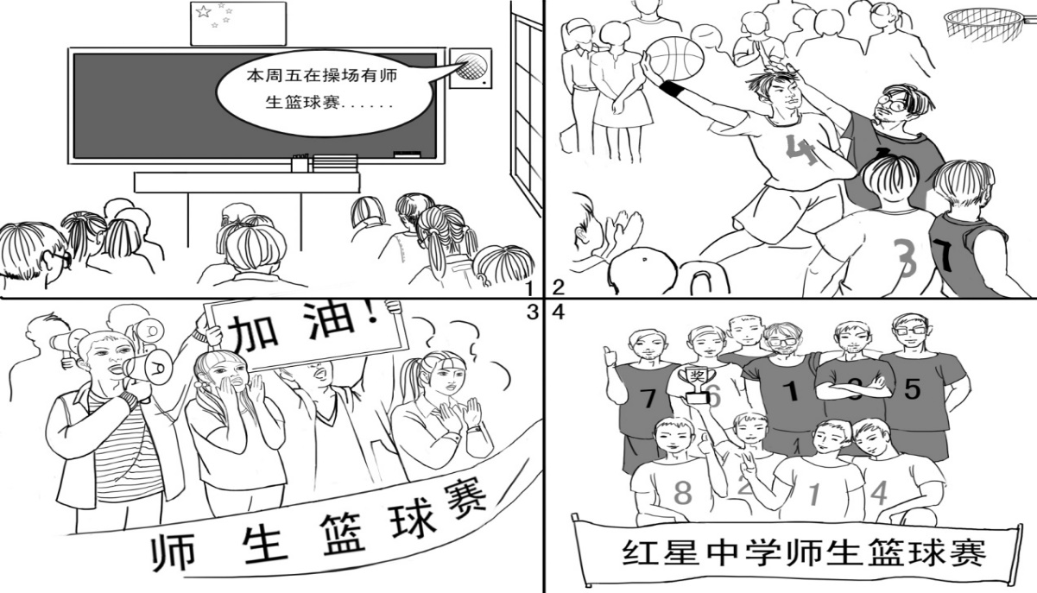
Recently our school held a basketball game between teachers and students to encourage the relationship between us. __________________________________________________________
______________________________________________________________________________

（请将情景作文写在答题纸指定区域内）
密云区高三年级阶段测试
英语答案 2017年9月

一、听力理解（共三节，30分）
第一节（共5小题；每小题1.5分，共7.5分）
1. B 2. A 3. B 4. C 5. C
第二节（共10小题；每小题1.5分，共15分）
6. C 7. A 8. B 9. A 10. B 11. B 12. C 13. A 14. A 15. C
第三节（共5小题；每小题1.5分，共7.5分）
★每小题超过一个词不计分； ★拼写错误不计分； ★16、17、18题的首字母要大写,否则扣0.5分，16题的所有字母都大写也计1.5分，20题首字母大写扣0.5分。
16. Schuller 17. International 18. Tuesday 19. 135 20. noon
二、单选
21-25 AAACB 26-30 BBDDC 31-35 CBBCD
三、完形
36. A 37. A 38. B 39. C 40. D 41. B 42. D 43. C 44. A 45. B
46. D 47. A 48. C 49. B 50. D 51. B 52. C 53. D 54. A 55. C
四、阅读理解
56-58 ABC 59-62 BDBD 63-66 CCAA 67-70 CBCC 71-75 AFEGC
五、写作
（一）应用文
Possible version:
Dear Sir or Madam,
I have learned that English volunteer guides for the Forbidden City are wanted in the summer vacation. I am writing to apply for this position.
I’m a Senior 3 student in Hongxing Middle School, and I believe I am qualified for the position. These years, I have been on several exchange programs in America, so I am confident with my communication skills in English. What’s more, as a fan of Chinese ancient history, I am sure my knowledge will prove helpful when I introduce the Forbidden City to foreign guests.
I would be very grateful if you could offer me the opportunity. Thank you for your consideration.
Yours
LiHua （113w）
（二）情景作文
Possible version:
Recently our school held a basketball game between teachers and students to encourage the relationship between us. It turned out to be an unforgettable experience.
Last Monday, the loudspeaker in the classroom announced that there was going to be a basketball game on the playground this Friday. Everybody was excited at the news. Soon two teams were formed and both trained hard for the game. Then came the big day. All the players competed against each other on the court and presented their remarkable basketball skills like slam dunking and jump shooting. Each of them tried their best to win. What a wonderful game!
Meanwhile, many teachers and students were cheering for the players on the sidelines. Some were holding up a sign saying “Go for it!” while others were screaming for their favorites. The atmosphere was charged with great excitement. Finally, the students won the game. Holding up the cup and standing side by side, all the players took a picture together to record this precious moment.
Through this activity, both teachers and students really enjoyed the game. Not only did we realize the importance of teamwork in the game but also we felt much closer to one another after that.

听力录音稿
Text 1 [来源:学_科_网Z_X_X_K]
M: I’m checking out now. Can I have my bill, please？
W: Sure. What’s your room number, sir?
M: It’s 8736. Here is my key card.
Text 2
M: Hi, I’m Lucas. I just moved in next door.
W: Oh, hi Lucas, come on in. I’m Barbara. Nice to meet you.
M: Nice to meet you, too.
Text 3
W: Are you going shopping?
M: Yes. I need some clothes for Alison’s wedding next week.
W: Aren’t you going to wear your blue suit?
M: Yes, but I need a new shirt to go with my tie.
Text 4
M: I got a traffic ticket this afternoon.
W: Were you parking in the wrong place or running a red light?
M: No, I was driving too fast.
Text 5
M: What flights do you have from New York to London tomorrow?
W: We have a non-stop flight leaving at 9:30 am.
M: When should I get to the airport?
W: Well, the boarding time is 9:00 am, so please be there by 8:30 am at the latest.
Text 6
M: You don’t look well. Are you OK? Don’t tell me you’re dieting again!
W: I’m just trying to lose weight the natural way.
M: The natural way? Remember those diets? In one diet, you only ate Monday, Wednesday and Friday. In another, you drank 50 cups of water a day!
W: Those diets didn’t work. I’m on a new diet that will surely make me slim again!
M: All right. What’s the secret diet?
W: I’m not telling you. You’ll only make fun of it.
M: No, I won’t. Tell me.
W: All right. I only eat orange-colored foods. I’ve eaten lots of oranges and carrots.
M: What?! Oranges? Carrots? You must have lost your mind!
Text 7
M: (Quietly) Why aren’t you doing your homework, Marsha?
W: I’ll do it later, Dad. I must practice the guitar first. Our group’s playing at a concert on Saturday.
M: (Laughs) Oh, is it? You’ll be making records next, will you?
W: We hope so. A famous musician is coming to the concert. So I’d better play well.
M: You’d better get on with your homework! You can practice all day Saturday.
W: Oh, Dad, you don’t understand at all! This concert could change my life!
M: It certainly could! You’ve got exams next month. Important ones! If you don’t get a good certificate, you won’t get a well-paid job.
W: (Rudely) I don’t need a certificate to play the guitar. And I don’t want a boring old job in a bank, either.
M: (Angrily) Oh, don’t you? Whose boring old job paid for this house? And for that guitar?
Text 8
M: Well, look at the map. This is the route I thought we could take on our hike.
W: How long is it altogether?
M: It’s about three miles.
W: That sounds OK. So, we start here at the car park and walk along the path to the waterfall.
M: Right. Then we turn left and walk up this small hill. The view from the top of the hill is worth the climb. We can eat a snack there.
W: Then we will follow this path down to the foot of the hill. We can see an old church there.
M: We can spend a few minutes looking around the church, and have our lunch outside the church, about two hours’ stay there. Then we walk along this path, turn south and come back to the car park.
W: How long do you think it will take us to complete the walk?
M: I think it will take about four hours, including breaks.
W: That’s fine. Are there road signs along the way, in case we get lost?
M: Yes, there are. They tell us which way to go and how far we have to walk.
Text 9
M: Welcome to our game show! Today’s guest, Julie Jones, is trying to win our grand prize, $30,000 in cash and an all-expense paid, six-day vacation to Hawaii. OK, Julie, to win the grand prize, you must answer all of the 3 true or false questions correctly. If not, you go home with a set of books or DVDs about cooking. Remember. When the buzzer goes off（插入声音）, you must give your answer. Are you ready?
W: I’m ready.
M: The first question: A cat has 32 muscles in each ear.（插入声音）
W: Uh. I remember it is 33, or 34. Oh, No! I think it’s true.
M: Correct! Question number two: A tuna is the only fish that can blink with both eyes.（插入声音）
W: True. I mean, I mean false. A shark is the only fish that can blink with both eyes.
M: Correct. The last question: An elephant is the largest animal on the earth.（插入声音）
W: False. A blue whale is the largest one.
M: Wow! Super!
W: Did I win?
M: Yes, Julie, pack your bags, and we’ll pack your wallet. You’re off to Hawaii!

Text 10
W: National Car Rental, can I help you?
M: I’d like to rent a car.
W: How long would you like to rent it?
M: 3 days, from next Tuesday to Thursday.
W: OK, what type of car would you like to have?
M: Urm, just the smallest type.
W: So it’ll be a Toyota. That’s £45 per day. So for three days, it’ll be £135 in total and it covers third party insurance, theft, fire and damage. But as for petrol, you need to pay for it yourself. So would you like to rent one?
M: Yes, please.
W: Now, what type of driving license have you got?
M: An international one.
W: OK. And your name and age?
M: My name is Ronald Schuller, R-O-N-A-L-D, S-C-H-U-L-L-E-R. I’m 33.
W: OK. What time would you like to pick up the car?
M: Well, say, around noon? Is that OK?
W: Around noon. No problem.

