word



陇东中学分校 2018-2019 学年第二学期期中考试试题高一英语

***注意事项：***

1. ***答题前填写好自己的姓名、班级、考号等信息;***
2. ***请将答案正确填写在答题卡上;***

一、单项选择**（共 15 小题，每空 1 分，满分 15 分）**

1. — I return the dictionary within three days?

学校: 姓名： 班级： 考号：

— No, you . You keep it for five days.

A. May; needn’t; will B. Can; mustn’t; would

C. Must; don’t have to; can D. Shall; can’t; should

1. Sir, you be sitting in this waiting room. It is for women and children only.

A. oughtn’t to B. can’t C. won’t D. needn’t

1. She is already two hours late. What to her?

A. can have happened B. must have happened

C. should have happened D. must happen

1. Mary the job he offered to her, but she didn’t.

A. can’t take B. ought to have taken

C. should take D. must have taken

1. He sat at the desk, a novel.

A. read B. to read C. reading D. reads

1. If you cheat in the exam, you could hardly it.

A. throw away B. get away C. get away from D. get away with

1. I know he hasn’t finished the work, but , he has done his best.

A. at all B. in all C. after all D. above all

1. Which food is called food, milk, sugar or beans?

A. energy-given B. body-building C. energetic D. protection

1. Li Lei isn’t stupid at all; , I think he is very clever.

A. in addition B. as a result C. on the contrary D. on the other hand

1. The girl hasn’t seen her mother for several years and she is looking forward her.

A. to see B. seeing C. to seeing D. and see

1. There is no doubt we will be successful.

A. whether B. what C. how D. that

1. She down her book and in bed.

A. lay; laid B. laid; lay C. lay; lay D. laid; laid

1. No potatoes for me — I’m a diet.

A. at B. in C. on D. with

1. The speed of cars and trucks is 30 kilometres per hour in large cities in China.

A. limited B. limiting C. limiting to D. limited to

1. Smoking is a bad habit. You should it.

A. throw away B. get away with C. get rid of D. throw

# 二、 完形填空（共 15 小题，每空 1 分，满分 15 分）

Everyone needs water and a diet of healthy foods. These foods should 1 some fat, some fiber, a little salt and so on.

People need energy to live. They eat all kinds of foods 2 change into energy. Our bodies use different 3 of energy. The energy is measured in calories(卡路里). The more

4 we take, the more calories we burn. Even when you are 5 , you are using energy — about 65

calories an hour. While you are at school, or walking home, your body is 6 up 100 calories an hour. When playing football or basketball, you might be using 400 calories an hour. On Sports Day, during the relay race, you will use most of all, perhaps as 7 as 650 calories an hour.

The Chinese diet is considered to be the healthiest in the world. It contains a lot of fruit and green vegetables. It is 8 in fiber and low in sugar and fat. The Chinese eat less sugar than many other countries in the world. That is 9 lots of people in China have white teeth.

People in the Western world do not eat such healthy foods. They eat too much fat and sugar and don’t take 10 exercise. Because of this, they 11 very easily. In order to

12 with the quick pace(步伐) of their life and work, they eat a lot of fast food. They eat a lot of

sweets, soft drinks, potato crisps, chocolate, butter and ice cream and so on, which are called

13 food by some epicureans(美食家). The result is that many of them become fat. In order to avoid 14 fat and 15 it is advisable(明智的) to eat a balanced diet and not eat too many foods that have a high calorie rating.

1. A. include B. hold C. contain D. make up
2. A. which B. what C. where D. it
3. A. numbers B. amounts C. plenty D. deal
4. A. exercise B. exercises C. sport D. game
5. A. sleepy B. running C. working D. asleep
6. A. running B. adding C. burning D. wasting
7. A. much B. many C. few D. little
8. A. poor B. low C. rich D. plenty
9. A. why B. because C. because of D. since
10. A. a number of B. too much C. masses of D. enough
11. A. lose weight B. put on weight C. die D. stay healthy
12. A. keep up B. carry on C. keep on D. go on
13. A. bad B. diseased C. healthy D. junk
14. A. to get B. becoming C. to become D. get
15. A. keep thin B. keep fit C. stay calm D. fall ill

… … … … ○ … … … … 外 … … … … ○ … … … … 装 … … … … ○ … … … … 订 … … … … ○ … … … … 线 … … … … ○ … … … …

… … … … ○ … … … … 内 … … … … ○ … … … … 装 … … … … ○ … … … … 订 … … … … ○ … … … … 线 … … … … ○ … … … …

第 1页共 8页 ◎ 第 2页共 8页

# 三、 阅读理解，根据短文内容选择最佳答案（共 20 小题，每空 2 分，满分 40 分）

A

People have strange ideas about food. For example, tomato is a kind of very delicious vegetable. It is one of useful plants that can be prepared in many ways. It has rich nutrition(营养) and vitamin in it. But in the 18th century, Americans never ate tomatoes. They grew them in their gardens because tomato plants are so pretty. But they thought the vegetable was poisonous(有毒的). They called tomatoes “poison apples”.

President Thomas Jefferson, however, know that tomatoes were good to eat. He was a learned man.

He had been to Paris, where he learned to love the taste of tomatoes. He grew many kinds of tomatoes in his garden. The President taught his cook a way for a cream of tomato soup. This beautiful pink soup was served at the President party. The guests thought the soup tasted really good. They never thought their president would serve his honoured guests poison apples. Jefferson never spoke to his honoured guests about the fact.

1. Tomato is a kind of .

A. poisonous fruit B. poisonous vegetable

C. tasty fruit D. tasty vegetable

1. After you read the passage, which of the following do you think is true?
   1. Americans never ate tomatoes after they began to plant them.
   2. Americans didn’t eat tomatoes before 19th century.
   3. Even now Americans don’t eat tomatoes.
   4. In the 18th century Americans ate a lot of tomatoes.
2. Jefferson learned that tomatoes were good to eat .

A. while he was in Paris B. when he was a little boy

C. because his parents told him so D. from books

1. From the passage we know all the honoured guests invited by Jefferson were .

A. people from other countries B. from France

C. people of his own country D. men only

1. According to the passage, which of the following is NOT true?
   1. None of the guests knew the soup that was served at the President party was made of tomatoes.
   2. All of the guests thought the soup which was prepared by the President’s cook was nice.
   3. President Thomas Jefferson knew that tomatoes were good to eat and not poisonous at all.
   4. All of the guests didn’t know that their president would serve his honoured guests poison

# B

|  |  |
| --- | --- |
| **Name** | Personal Information |
| **Fei Junlong** | * Born in 1965 in Jiangsu, China * An astronaut * Traveled in Shengzhou VI in outer space with Nie Haisheng   from October 12th to October 17th, 2005 |
| **Yao Ming** | * Born in Shanghai in 1980 * The son of two great basketball players * Joined the Houston Rockets in November, 2002 |
| **Zhou Jielun** | * Born in 1979 in Taiwan, China * A popular singer * Favorite music:Hip-Hop |
| **AlfredNobe l**  **(1833-1896)** | * Born in Sweden * A scientist * Known for the Nobel Prizes |
| **Helen Keller (1880-1968)** | * Not able to see or hear * Worked hard and became one of the famous women writers in America * Wrote a lot, such as, *The story of My Life* |

1. Fei Junlog and Nie Haisheng traveled in outer space for days.

A. two B. five C. seven D. nine

1. Yao Ming’s parents were great players before.

A. basketball B. football C. volleyball D. tennis

1. The was born in 1833.

A. player B. singer C. scientist D. astronaut

1. *The Story of My life* is the name of a .

A. sport B. song C. prize D. book

1. Which of the following is true?
   1. Yao Ming joined the Houston Rockets in October, 2002.
   2. Zhou Jielun is from Shanghai, China.
   3. Alfred Nobel was famous for the Nobel Prizes.
   4. Helen Keller could see and hear.

# C

Some British and American people like to invite friends for a meal at home. You should not be upset if your English friends don’t invite you home. It doesn’t mean they don’t like you!

… … … … ○ … … … … 内 … … … … ○ … … … … 装 … … … … ○ … … … … 订 … … … … ○ … … … … 线 … … … … ○ … … … …

※※请※※不※※要※※在※※装※※订※※线※※内※※答※※题※※

… … … … ○ … … … … 外 … … … … ○ … … … … 装 … … … … ○ … … … … 订 … … … … ○ … … … … 线 … … … … ○ … … … …

第 3页共 8页 ◎ 第 4页共 8页

Dinner parties usually start between 7and 8 pm and end at about 11pm. Ask your hosts what time you should arrive. It’s polite to bring flowers, chocolates or a bottle of wine as a gift.

Usually the evening starts with drinks and snacks. Do you want to be extra polite? Say how much you like the room, or the pictures on the wall. But remember –it’s not polite to ask how much things cost. In many families, the husband sits at one end of the table and the wife sits at the other end, they eat with their guests.

You’ll probably start the meal with soup or something small, then you’ll have meat or fish with vegetables, and then dessert, followed by coffee. It’s polite to finish everything on your plate and to take more if you want to. Did you enjoy the evening? Call your hosts the next day, or write them a short “thank you” letter. British and American people like to say “thank you, thank you, thank you” all the time!

学校: 姓名： 班级： 考号：

1. An English doesn’t invite you to his or her home, which .

A. means he or she doesn’t like you B. means he or she likes you

C. doesn’t mean he or she likes you D. doesn’t mean he or she doesn’t like you

1. You are going to attend a dinner party, and .
   1. you’d better bring a certain present with you
   2. you must leave home for it at 7 pm
   3. you should ask your host when you should leave
   4. you must arrive at it before 8 pm
2. Usually the evening starts with .

A. soup or something small B. drinks and snacks

C. meat or fish D. dessert

1. In which order will you eat or drink the following things at the meal?
   1. Snacks, vegetables, meat, coffee.
   2. Coffee, drinks, soup, fish, vegetables, dessert.
   3. Soup, meat with vegetables, dessert and coffee.
   4. Drinks, soup, something small, fish and vegetables.
2. Which is the good manners in which you express your enjoyment of the evening?
   1. Before leaving for home, you should say, “Thank you for inviting me.”
   2. When you shake hands with your host, you should say, “I did enjoy the evening.”
   3. You can write a “thank you” letter to your host after that.
   4. You should finish everything on your plate and take more if you want to.

# D

Most things can not be enjoyed without friends, but reading can. While sitting in houses, we can travel around the world, and we can read the reasons for thousands of things. Living in this age, we can talk with those who lived many years ago. Although we may be unworthy, we can become friends of wise men. Only books can give us these pleasures. Those who can’t enjoy them are poor people while those who enjoy them most get the most happiness from them.

1. From the passage we can see .
   1. anything can be enjoyed without friends except reading
   2. only reading can be enjoyed without friends
   3. reading can be enjoyed without friends
   4. nothing but reading can be enjoyed without friends
2. By reading we can know .
   1. what is going on in the outside world
   2. what happened many years ago
   3. wise men are not worth making friends with
   4. both A and B
3. It is possible for us to talk with those who lived many years ago because .

A. we have a good memory B. reading can help us

C. they are still alive D. they were our good friends

1. Those who can get the most happiness from books.

A. like reading B. are not interested in reading

1. never force themselves to keep on reading
2. are living in this age
3. The best title for this passage is “ ”.

A. Read Carefully and Learn B. Reading Gives Pleasure

C. How to Get a Good Book D. Reading is No Use

# 四、英汉互译（共 30 小题，每空 1 分，满分 30 分）

1. 发生 2. 代替… 3. 纪念，追念 4. 需要 5. 以防万一 6. 嘲笑，戏弄别人 7. 瞧不起， 看轻 8. 仿佛，好像 9. 屏息，屏气 10. 计划去做某事 11. 对…有害 12. 和…结婚

13. 节食，控制饮食 14. 被放过，做坏事不受惩罚 15. 赢回；重新获得

… … … … ○ … … … … 外 … … … … ○ … … … … 装 … … … … ○ … … … … 订 … … … … ○ … … … … 线 … … … … ○ … … … …

… … … … ○ … … … … 内 … … … … ○ … … … … 装 … … … … ○ … … … … 订 … … … … ○ … … … … 线 … … … … ○ … … … …

第 5页共 8页 ◎ 第 6页共 8页

16. spot sb. doing sth. 17. account for 18. seek for 19. on the contrary 20. as a matter of fact 21. be rude to… 22. make a bet 23. take a chance 24. bring up 25. go ahead

26. with patience 27.in rags 28.throw down 29.have sb. doing sth. 30.had better do sth.

# 五．根据提示完成句子（共 9 小题，每空 0.5 分，满分 10 分）

1. Festivals are 1 to 2 important times of year.

节日就是庆祝一年中重要的日子。

1. At that time people would 3 if food was 4 to find,_especially during the cold winter

months. 在当时，如果食物难以找到，人们就会挨饿，特别是在寒冷的冬季。 3．The country, 5 6 cherry tree flowers, looks as though it is covered with pink snow. 整个国度到处是盛开的樱花，看上去就像覆盖了一层粉红色的雪。

1. It was 7 that the manager of the coffee shop was waiting for Li Fang to leave...

很明显，咖啡馆的经理在等李方离开……

1. 8 9 10 11 (没有什么更好了)than an ice-cream on a hot summer afternoon.
2. You have been working all day. You 12 13 14 (一定累了).
3. It’s time for class now，but our teacher hasn’t 15 16 (出现).
4. Mr. Wang is a man who always 17 18 19 (守信用).
5. If you want to catch the first bus, you’d better 20 off for (动身去)the station immediately.

六、短文改错（每小题 0.5 分,共 5 分**）**

Dear Elli，

I’m a senior student. I like mak friend with 1. people and I do my best to get on well for everyone. 2. But last week I find that one of my friends 3. wrote in her English diary that she dislikes me. 4. He doesn’t want to be my friend any more. Now 5. she has started making fun of me because of I’m 6. fat. I am kind to her but why can’t she be friendly 7. towards me? My other problem is try to lose weight. 8. Do I do more exercises? Use pills? And do you 9. know any other way？Please give me some advices. 10.

Yours,

Mary

# 七、书面表达（满分 5 分）

Hualian Supermarket 里面的部分水果和蔬菜正在降价销售。请你根据图片提示，为 Hualian

Supermarket 写一则促销广告。

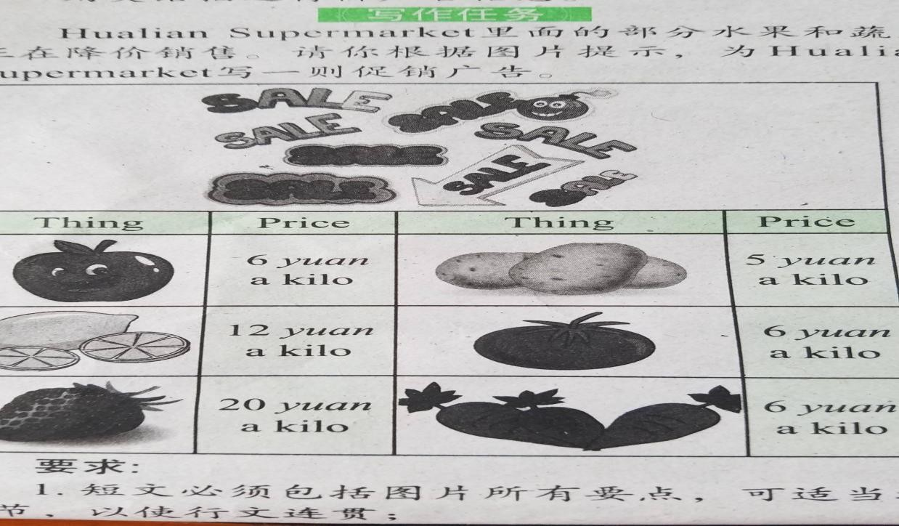

# Eg:The apples are only 6 yuan a kilo! The lemons are 12 yuan a kilo! （用所提示的句型写作)

… … … … ○ … … … … 内 … … … … ○ … … … … 装 … … … … ○ … … … … 订 … … … … ○ … … … … 线 … … … … ○ … … … …

※※请※※不※※要※※在※※装※※订※※线※※内※※答※※题※※

… … … … ○ … … … … 外 … … … … ○ … … … … 装 … … … … ○ … … … … 订 … … … … ○ … … … … 线 … … … … ○ … … … …

第 7页共 8页 ◎ 第 8页共 8页