巩固拓展案十四
学 案 装 订 线

第一节 （共 15 小题；每小题 2 分，满分 30 分）
阅读下列短文，从每题所给的四个选项（A、B、C、和 D）中，选出最佳选项。
A
Here are some of the movies that inspire you to travel.
The Lord of the Rings
The story is about Frodo, his friends and their adventurous journey through Middle Earth. Filmed in about 150 locations all over New Zealand, this traveling movie shows its beauty. From the rolling hills of Matamata to the volcanic region of Mt Ruapehu, this is the best movie to see New Zealand. Also, this travel movie might have the only distinction of being inspired by travel too. The director of the movie Peter Jackson first read the novel on a train going from Wellington to Auckland when he was just seventeen.
Indiana Jones: The Complete Adventure Collection
Indiana Jones and travel are inseparable. Everyone remembers the red line on the world map that shows up on screen when he flies. The Egypt scenes in Raiders of the Lost Ark were filmed in Tunisia. Temple of doom was filmed mostly in Sri Lanka and Macau. The Last Crusade was filmed in Italy, Spain and Jordan including an excellent view of Petra. Unlike the other, Kingdom of the Crystal Skull was filmed almost entirely in the United States. However, their shots of Iguazu Falls are amazing.
Romancing the Stone and jewel of the Nile
This movie series focuses on a romance writer Joan and her adventures with a soldier of fortune named Jack. In Romancing the stone Joan goes to Colombia to save her sister who was kidnapped(绑架). In the sequel Joan goes to the fictional kingdom of Kadir set somewhere in the Middle East. Romancing the stone's scenes were shot mostly in Mexico. For Jewel of the Nile, the scenes were mostly shot in France and Morocco.
The Talented Mr Ripley
Tom Ripley is a working class young man. Through a case of mistaken identity, he is asked to go to Italy to convince a wealthy businessman's son to come home. This travel movie starts in New York and heads to the fictional resort of Mongibello. The last section of the movie is filmed mostly in Rome and Naples. The locations are beautiful. They also did a good job of showing Italy as it looked in the 1960s.
1. If someone is interested in seeing views in Sri Lanka, he would most probably watch the film ________.
A. Indiana Jones: The Complete Adventure Collection B. Romancing the Stone and jewel of the Nile
C. The Lord of the Rings D. The Talented Mr Ripley
2. From Paragraph 2 we can know that the story of The Lord of the Rings ________.
A. is the best movie made in New Zealand
B. was shot from Wellington to Auckland
C. encouraged a 17-year-old boy to travel in New Zealand
D. caught the director's attention while he was travelling
3. The movie The Talented Mr. Ripley tells us a story of a man who ________.
A. owns a large amount of fortune B. contributes to helping a man out of trouble
C. goes sightseeing in Rome and Naples D. becomes wealthy by always working hard
B
It was not until I was 9 years old that I found out my father was ill. It was 1994, but I can remember my mother's words as if it were yesterday: "Kernel, I don't want you to take food from your father, because he has AIDS. Be very careful when you are around him." AIDS wasn't something we talked about in my country when I was growing up. From then on, I knew that this would be a family secret. My parents were not together anymore, and my dad lived alone. For a while, he could take care of himself. But when I was 12, his condition worsened. My father's other children lived far away, so it fell to me to took after him.
We couldn't afford all the necessary medicine for him, and because Dad was unable to work, I had no money for school supplies and often couldn't even buy food for dinner. I would sit in class feeling completely lost.The teacher's words muffled as I tried to figure out how I was going to manage. I did not share my burden with anyone. I had seen people’s reaction to AIDS. Kids laughed at classmates who had parents with the disease. And even adults could be cruel. When my father was moved to the hospital, the nurses would leave his food on the bedside even though he was too weak to feed himself.
I had known that he was going to die, but after so many years of keeping his condition a secret, I was completely unprepared when he reached his final days. Sad and hopeless, I called a woman at the nonprofit National AIDS Support. That day, she kept me on the phone for hours. I was so lucky to find someone who cared. She saved my life.
I was 15 when my father died. He took his secret away with him, having never spoken about AIDS to anyone, even me. He didn't want to call attention to AIDS. I do.
4. What does Kernel tell us about her father?
A. He had stayed in the hospital since he fell ill. B. He worked hard to pay for his medication.
C. He told no one about his disease. D. He was carefully attended by the nurses on his deathbed
5. What can we learn from the underlined sentence?
A. Kernel found what the teacher said hard to understand. B. Kernel had special difficulty in hearing.
C. Kernel was too tired to hear her teacher's words. D. Kernel was too troubled to focus on the lesson.
6. Why did Kernel keep her father's disease a secret?
A. She wanted to obey her mother. B. She was afraid of being looked down upon.
C. She found no one willing to listen to her. D. She thought it was shameful to have AIDS.
7. What’s the author’s purpose in writing the text?
A. To tell people about the sufferings of her father B. To prove how little people knew about AIDS.
C. To draw people’s attention to AIDS. D. To recall a hard time of her childhood.
C
Music is something that every person has his or her own specific opinion about. Different people have different tastes, and various types of music have many ways of leaving an impact (影响) on someone. It can be relaxing, angering, comforting, energizing, and many more.
There are so many types of music out there today. Rap, pop, rock, country, alternative, hardcore are some of the abundant types in the world. Music sends out either good or bad messages that have big impacts on how people act. People usually become friends with others who have the same taste. People may not want to associate with people who have different tastes in music because they’ll argue about what they think is better but it’s just their own opinions.
Rap and Rock music are two very important types of music in the world. The lyrics (歌词) sung or rapped by the artists can be things going on in their own personal lives. Music can also serve as a motivation for new ideas. When people listen to the new things out there, they learn different things going on in the world and they become more open minded because they’re exposed to different people like the artists.
People can use music to express themselves in ways it can’t be expressed through behavior, or art. You can usually tell how someone feels by the type of music he or she is listening to at the time. It’s a tool used by many. Groups of people around the world can come together and gather at concerts and shows to what their interests and liking are and you see how many people have similar likings as you.
8. What can we know about music according to the first paragraph?
A. All people like listening to music in some way.
B. Preference for music varies from person to person.
C. There are four kinds of impact music can bring about.
D. Different types of music have the same impact on people.
9. People are likely to become friends because of ________.
A. the same taste of music B. the good impact of music
C. the attraction of different ideas D. the arguments about music style
10. Music can serve as a motivation for new ideas by ________.
A. giving listeners controversial lyrics B. setting up role models like the artists
C. opening listeners’ mind to new thoughts D. impressing listeners with familiar images
11. What can we know from the last paragraph?
A. The music you like shows who you are.
B. Music expresses oneself better than behavior.
C. The music one listens to determines his or her feeling.
D. Music is tool to make different people become friends.
D
Scientists have found that human eyes are more likely to be damaged by UV rays while skiing in the snow-covered areas than sitting on the beach, according to a report by the UK newspaper.
The researchers at Kanazawa Medical University, Japan and American company Johnson & Johnson conducted the study together. They looked at the effects of light reflection on newly fallen snow on a ski trail in Ishikawa District, northern Japan. They compared the results with the levels of UV rays on a sand beach in southern Japan's Okinawa District.
They found that on the beach, eyes are exposed to a daily 260 kilojoules (千焦耳) of UV a square meter compared to 658 kilojoules in snow-covered areas.
The findings are supported by the Japan Meteorological (气象的) Agency. According to the agency, the reflection rate of UV light on beaches is often between 10 and 25 percent, compared to 80 percent in the new snow areas. The amount of light increased 4 percent with a 300-meter rise in height.
Most of us know that UV rays can harm the skin. That's why we wear sunscreen on our skin before we get out in the sun. But many of us may not realize that UV rays are also harmful to the eyes.
If your eyes are exposed to large amounts of UV radiation over a short period of time, you may experience a kind of sunburn of the eye, which is harmful. Your eyes will become red and feel a strange feeling. They may be sensitive to light. Fortunately, this is usually temporary and seldom causes permanent damage to the eyes.
Long-term exposure to UV radiation, however, can be more serious. Scientific studies and researches have shown that exposure to small amounts of UV radiation over a period of many years increases the chance of eye damage, which could lead to total blindness.
12. You would most likely find the article in .
A. a doctor's diary B. a travel journal
C. a medical magazine D. a physics textbook
13. Which of the following statements is TRUE according to the passage?
A. Too much eye exposure to UV rays may cause total blindness.
B. Short-time exposure of the eyes to UV rays doesn't harm them at all.
C. Most people know that UV rays harm the eyes as well as the skin.
D. The study was conducted by researchers from Japan, the USA and the UK.
14. Human eyes are more likely to be damaged by UV rays while skiing in the snow-covered areas than sitting on the beach because .
A. Snow produces more UV light than water.
B. People don’t wear sunscreen while skiing as they do while sitting on the beach.
C. The reflection rate of UV light in snow-covered areas is much higher than that on the beach.
D. Human eyes are exposed longer to UV light in the snow- covered areas than on the beach.
15. What will the passage most probably talk about next?
A. Never ski on newly fallen snow in Japan.
B. Go to hospital to have your eyes examined.
C. Wearing a hat can provide protection while skiing in new snow areas.
D. Take some measures to protect your eyes while skiing in new snow areas.
第二节（共5小题；每小题2分，满分10分）
根据短文内容，从短文后选项中选出能填入空白处的最佳选项。选项中有两项为多余选项。
From an early stage in your life, you are taught to respect others, and do kind things for them. However, in some cases, people begin to take advantage of your kind nature, expecting more from you.___16___ If you feel as if there are people in your life who take you for granted, it’s time to protect yourself.
Know that you have the right to feel respected. Social and cultural pressures may encourage you to believe that it’s rude to say “no” to others when they ask you for things. You may also have been taught to feel that your work is less valuable than others’ and does not deserve recognition .___17___. Everyone has the right to be respected and appreciated, and it isn’t wrong to want to be treated that way.
Identify what has changed in the relationship. If you feel taken for granted, it may be because you once felt valued by the person who is now taking you for granted. It might also be because the knowledge that you should feel appreciated but do not .___18___. It can also help you find a solution for the relationship.
___19___.You know that you don’t want to feel taken for granted. But what do you want？It will be hard to see any change in your situation if you feel vague dissatisfaction but have no clear ideas on what would improve it. ___20___.Once you know the change about the relationship clearly, you’ll be able to take better action to get you there.

A. Think about what you want.
B. Practice what you want to say.
C. These things can lead to you feeling taken for granted.
D. Try making a list of things that you would like to see the change about the relationship.
E. If you feel taken for granted by others, you need to communicate that to the other person.
F. Such people may repeatedly ask you for favors without returning any favors or showing you any respect.
G. Whatever the cause is, identifying what has changed your interactions with the other person can help you feel better.
第三节 完形填空（共20小题；每小题1.5分，满分30分）
阅读下面短文，从短文后各题所给的四个选项（A、B、C 和 D）中，选出可以填入空白处的最佳选项，并在答题卡上将该项涂黑。
In the early spring of 1974, the now world-famous photographer Stephen Wilkes was a 16- year-old reporter and cameraman for his high school’s television station. His best friend was also a reporter for the ___21___, and together they came up with the wild idea of___22___some of the great news broadcasters and journalists of the age. So they wrote personalized, hand-written letters to dozens of them.
Nobody ___23___but perhaps the greatest news broadcaster and journalist of them all: Walter Cronkite, who generously offered to spend a full ___24___ with the boys. Stephen and his friend understood that this would be the most ___25___reporting event of their lives, so they prepared___26___for it.
They___27___dozens of thoughtfully well-prepared questions and practiced the questions over and over again. When the day of the interview ___28___, they were ready. They sat with Mr. Cronkite and asked him one question after another, carefully___29___each question on their notepad. And Mr. Cronkite was unbelievably_____30_____ with his answers for the entire hour.
Then, as they were_____31_____ things up, he said, “Boy, I’d like to ask you both an important question; Do you know what makes a _____32_____interview?”
Stephen and his friend were caught off-guard, so they quickly began searching _____33_____their notepad, which didn’t provide an obvious _____34_____. Mr. Cronkite smiled and quickly rescued them, _____35_____. “Being a good listener, boys. That’s what truly makes a great interview. Being a good _____36_____will always lead you to the next best question.”
The boys looked up at the legendary broadcaster and suddenly _____37_____ they had spent their whole hour robotically _____38_____one scripted(照本宣科的) question after another meaninglessly, but not truly listening or _____39_____to a single answer. And if they had listened, they could have allowed Mr. Cronkite’s answers to guide their question, and guide them to a far more _____40____ hour together.
21. A. company B. station C. town D. country
22. A. becoming B. knowing C. studying D. interviewing
23. A. replied B. cared C. accepted D. believed
24. A. minute B. hour C. day D. week
25. A. challenging B. fortunate C. important D. rewarding
26. A. separately B. anxiously C. independently D. carefully
27. A. gathered B. employed C. received D. composed
28. A. passed B. ended C. arrived D. occurred
29. A. looking at B. breaking down C. leaving up D. checking off
30. A. patient B. funny C. strange D. wise
31. A. making B. packing C. turning D. cleaning
32. A. slow B. peaceful C. great D. content
33. A. for B. inside C. through D. with
34. A. way B. answer C. favor D. chance
35. A. complaining B. warning C. declaring D. explaining
36. A. listener B. reporter C. broadcaster D. cameraman
37. A. mastered B. realized C. expected D. remembered
38. A. showing B. donating C. asking D. guiding
39. A. responding B. sticking C. objecting D. agreeing
40. A. effective B. unforgettable C. interesting D. meaningful

巩固拓展案十四答案解析
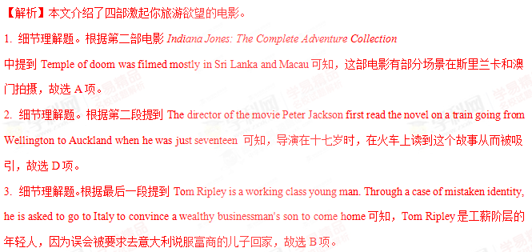
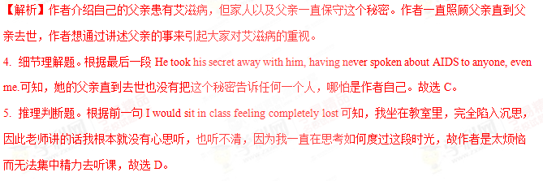
6. 推理判断题。第二段I had seen people reacted to AIDS. Kids laughed at classmates who had parents with the disease. And even adults could be cruel.可知，作者怕别人知道了也会嘲笑她，故选B。
7. 推理判断题。根据最后一段He didn't want to call attention to AIDS. I do.可知，作者的父亲不想让艾滋病引起大家的注意，但是作者想让大家注意艾滋病，对艾滋病重视起来，故选C。
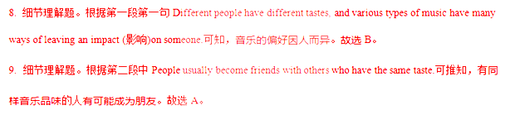
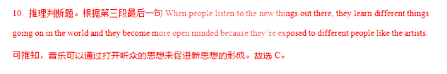
11.根据最后一段第一、二句People can use music to express…. You can usually tell how someone feels by the type of music he or she is listening to at the time.由此可推知，你喜欢的音乐能表明你是什么样的人，但不是音乐能比行为更好的表达自己，也不是听的音乐决定了人的感受；再根据常识，音乐不是让不同的人变成朋友的工具，而是通过音乐可以了解到不同的人对音乐的喜好，故排除D。
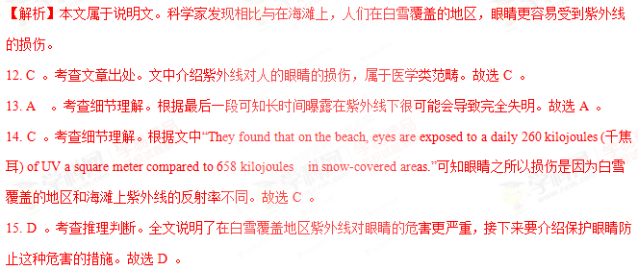
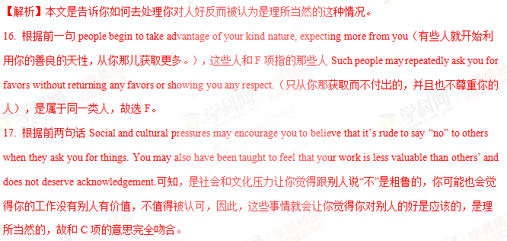
18. 根据后一句的关键词It can also help you...以及本段的第一句Identify what has changed in the relationship.可知，与G项Whatever the cause is, identifying what has changed your interactions with the other person can help you feel better.中的关键词完全吻合，故选G。
19. 根据后两句中的关键词you don’t want和what do you want 可知，本段是讨论你想要的东西，故选A。
20. 根据前一句It will be hard to see any change in your situation if you feel vague dissatisfaction but have no clear ideas on what would improve it.可知，你很难看到你所处环境的变化，也不知道怎么去提高，因此接下来说的就是告诉你如何去做；再根据后句Once you know the change about the relationship clearly, you’ll be able to take better action to get you there.“一旦你清楚地了解了这段关系的变化，你就能采取更好的行动把你带到那里。”可知，前一句是涉及到关系的变化，故D项“试着列出你想看到的变化的关系。”承接上下文。故选D。
21. 考查名词。A. company公司；B. station电视台，车站；C. town城镇；D. country国家。根据上文的a 16- year-old reporter and cameraman for his high school’s television station可知，他最好的朋友也是电视台的一名记者。故选B。
22. A. becoming变成；B. knowing知道；C. studying学习；D. interviewing采访，面试。因为他们是记者，所以他们提出的疯狂想法应该是采访一位伟大的新闻广播员和时代的记者。
23. 考查动词。A. replied回答；B. cared照顾，关心；C. accepted接受；D. believed相信。根据上句：他们给他们写了几十封个性化的手写信。再根据本句中的but（除……之外）可推知，除了Walter Cronkite之外没人回信。故选A。
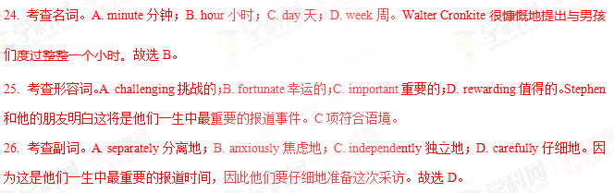
27. 考查动词。A. gathered聚集；B. employed雇佣；C. received收到；D. composed组成，作曲。他们收集了许多精心准备的问题，并且反复地练习。故选A。
28. 考查动词。A. passed通过；B. ended结束；C. arrived到达；D. occurred发生。当采访的那一天到来的时候，他们做好了准备。故选C。
29. 考查动词词组。A looking at看；B. breaking down毁掉；C. leaving up离开；D. checking off核对。他们一个接一个问题地问Mr. Cronkite，并在笔记本上仔细地核对每个问题。故选D。
30. 考查形容词。A. patient耐心的；B. funny有趣的；C. strange奇怪的；D. wise明智的。Mr. Cronkite整个被采访的一个小时非常耐心地回答问题。故选A。
31. 考查动词。A. making制造；B. packing打包，包装；C. turning转变；D. cleaning打扫。当他们收拾东西的时候，他问了男孩一个重要的问题。故选B。
32. 考查形容词。A. slow慢的；B. peaceful平静的；C. great伟大的；D. content满意的。你知道什么创造一次伟大的采访吗？第15空下句有提示That’s what truly makes a great interview.
33. 考查介词。A. for为了；B. inside在……里面；C. through穿过……；D. with和……一起。Stephen和他的朋友猝不及防，所以他们快速地搜索笔记本。search through 搜遍，搜查，故选C。
34. 考查名词。A. way方法；B. answer答案；C. favor好感；D. chance机会。他们搜索笔记本，但上面没有提供明显的答案。故选B。
35. 考查动词。A. complaining抱怨；B. warning警告；C. declaring宣布；D. explaining解释。他们没找到答案，Mr. Cronkite很快救了他们，解释说“成为一名好的听众”会创造一次伟大的采访。
36. A. listener听众；B. reporter记者；C. broadcaster广播员；D. cameraman摄影记者。根据上句中的Being a good listener可知，此处选A。做一个好的倾听者总会引导你进入下一个最好的问题。
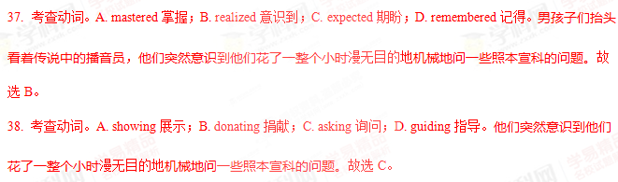40. 考查形容词。A. effective有效的；B. unforgettable难忘的；C. interesting有趣的；D. meaningful

In the early spring of 1974, the now world-famous photographer Stephen Wilkes was a 16- year-old reporter and cameraman for his high school’s television station. His best friend was also a reporter for the ___21___, and together they came up with the wild idea of___22___some of the great news broadcasters and journalists of the age. So they wrote personalized, hand-written letters to dozens of them.
Nobody ___23___but perhaps the greatest news broadcaster and journalist of them all: Walter Cronkite, who generously offered to spend a full ___24___ with the boys. Stephen and his friend understood that this would be the most ___25___reporting event of their lives, so they prepared___26___for it.
They___27___dozens of thoughtfully well-prepared questions and practiced the questions over and over again. When the day of the interview ___28___, they were ready. They sat with Mr. Cronkite and asked him one question after another, carefully___29___each question on their notepad. And Mr. Cronkite was unbelievably_____30_____ with his answers for the entire hour.
Then, as they were_____31_____ things up, he said, “Boy, I’d like to ask you both an important question; Do you know what makes a _____32_____interview?”
Stephen and his friend were caught off-guard, so they quickly began searching _____33_____their notepad, which didn’t provide an obvious _____34_____. Mr. Cronkite smiled and quickly rescued them, _____35_____. “Being a good listener, boys. That’s what truly makes a great interview. Being a good _____36_____will always lead you to the next best question.”
The boys looked up at the legendary broadcaster and suddenly _____37_____ they had spent their whole hour robotically _____38_____one scripted(照本宣科的) question after another meaninglessly, but not truly listening or _____39_____to a single answer. And if they had listened, they could have allowed Mr. Cronkite’s answers to guide their question, and guide them to a far more _____40_____ hour together.
21. A. company B. station C. town D. country
22. A. becoming B. knowing C. studying D. interviewing
23. A. replied B. cared C. accepted D. believed
24. A. minute B. hour C. day D. week
25. A. challenging B. fortunate C. important D. rewarding
26. A. separately B. anxiously C. independently D. carefully
27. A. gathered B. employed C. received D. composed
28. A. passed B. ended C. arrived D. occurred
29. A. looking at B. breaking down C. leaving up D. checking off
30. A. patient B. funny C. strange D. wise
31. A. making B. packing C. turning D. cleaning
32. A. slow B. peaceful C. great D. content
33. A. for B. inside C. through D. with
34. A. way B. answer C. favor D. chance
35. A. complaining B. warning C. declaring D. explaining
36. A. listener B. reporter C. broadcaster D. cameraman
37. A. mastered B. realized C. expected D. remembered
38. A. showing B. donating C. asking D. guiding
39. A. responding B. sticking C. objecting D. agreeing
40. A. effective B. unforgettable C. interesting D. meaningful
【答案】21. B 22. D 23. A 24. B 25. C 26. D 27. A 28. C 29. D 30. A 31. B 32. C 33. C 34. B 35. D 36. A 37. B 38. C 39. A 40. D

