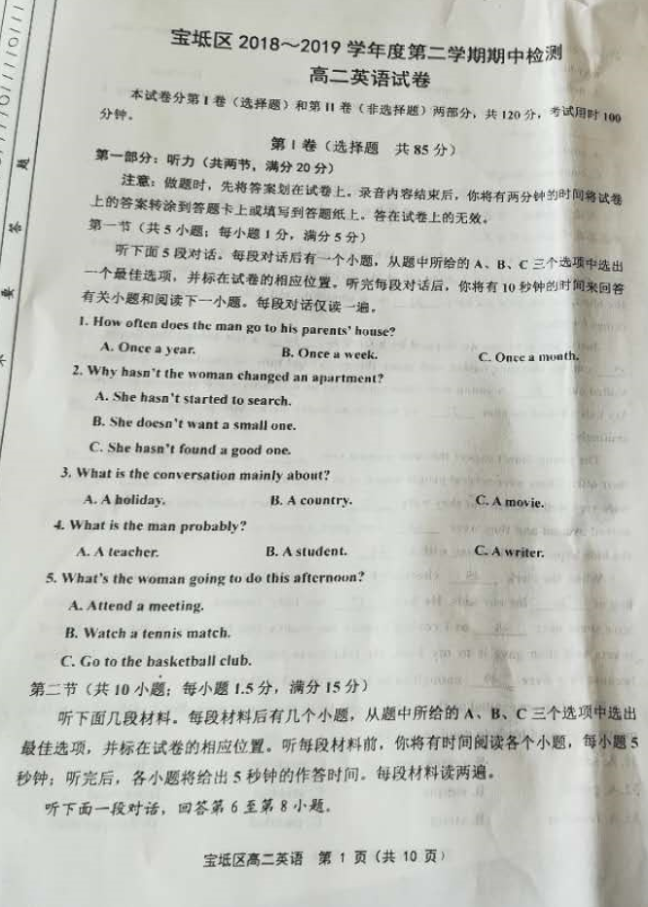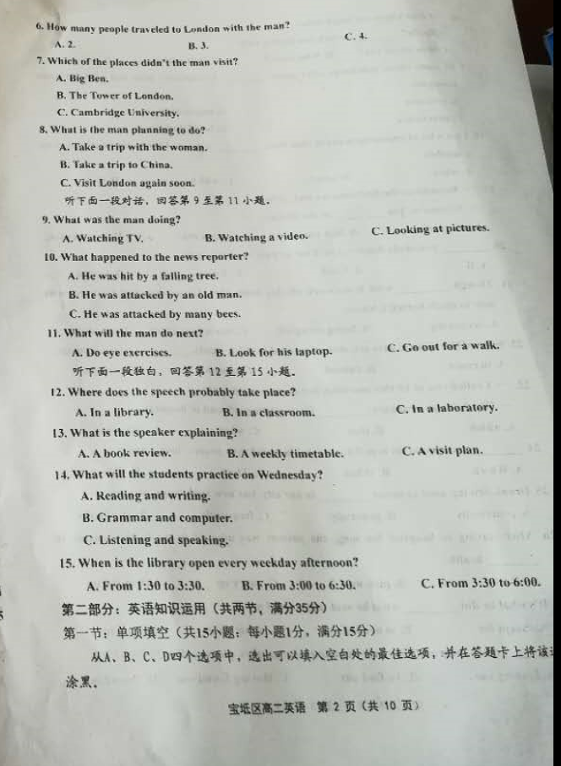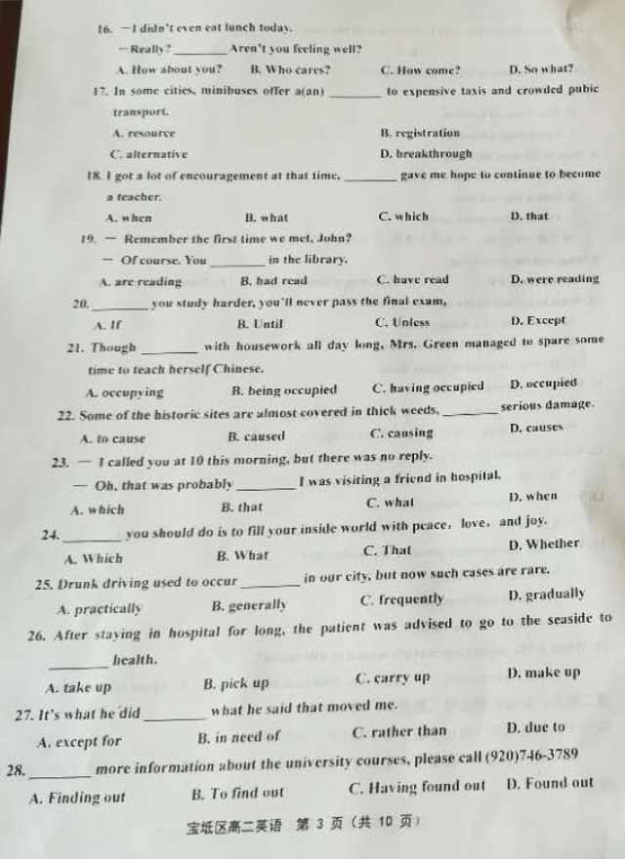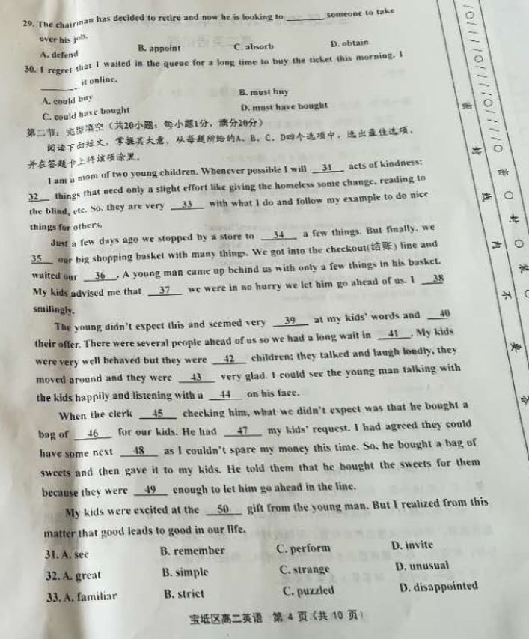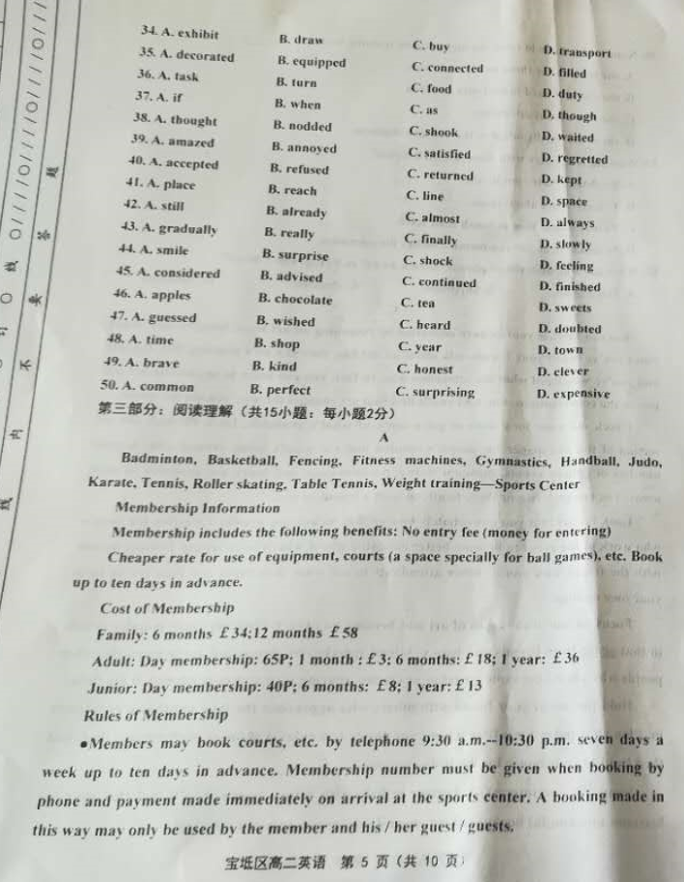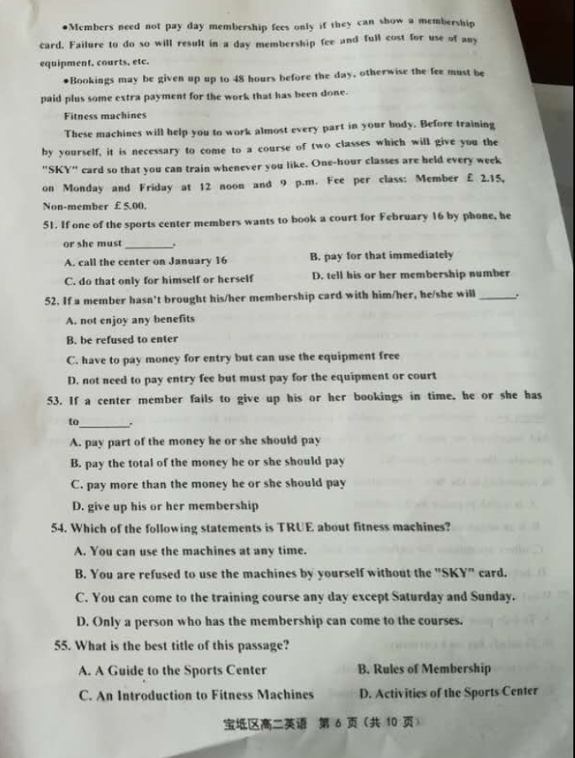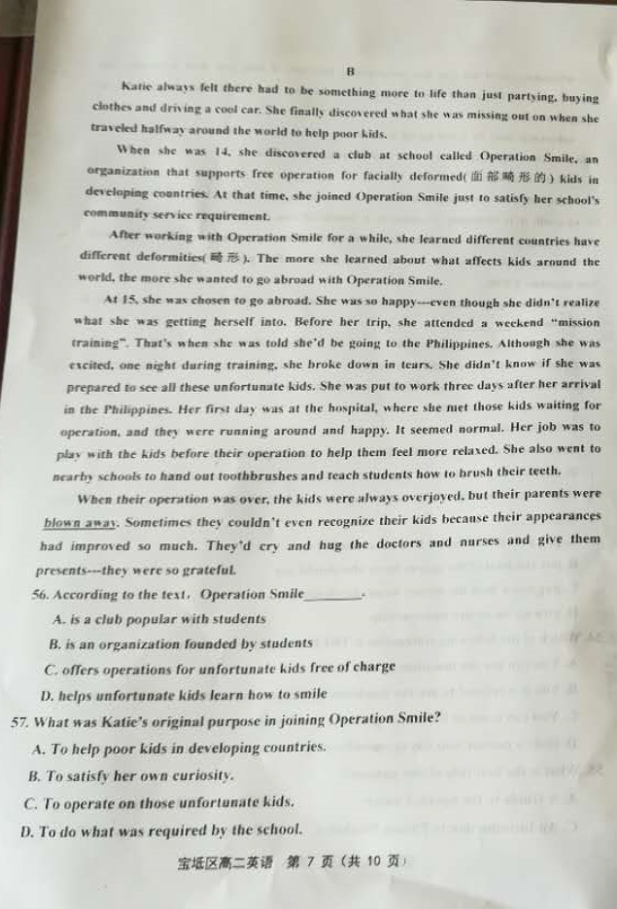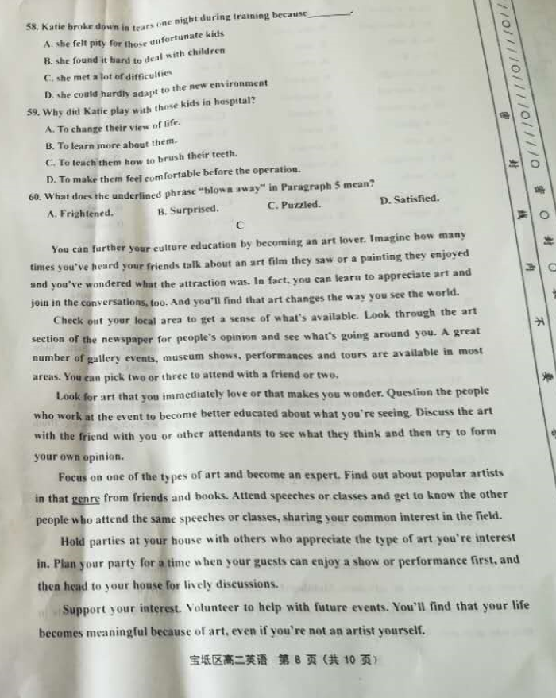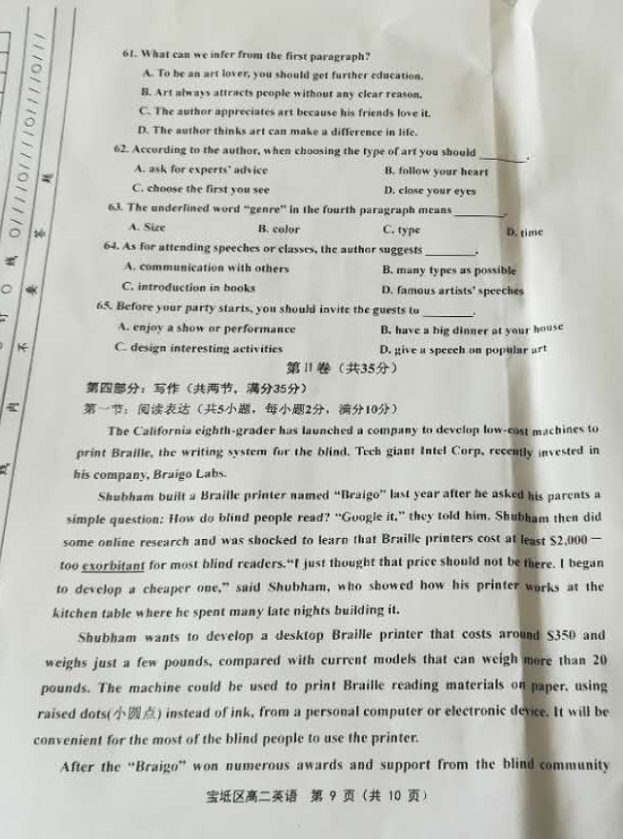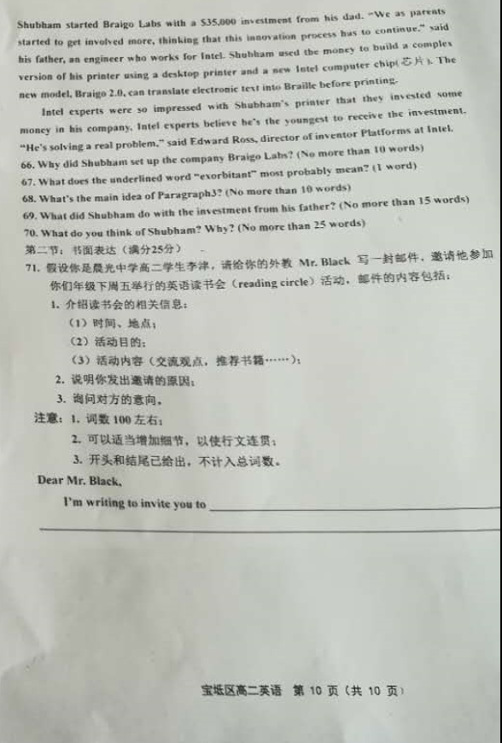
宝坻区2018～2019学年度第二学期期中检测
高二英语参考答案
选择题
听力：1—5 BCABA 6—10 BCBBC 11—15 CBBCC
单选：16—20 CCCDC 21—25 DCDBC 26—30 BCBBC
完型：31－35 CBACD 36－40 BCBAA
41－45 CABAD 46－50 DCABC
阅读：51-55 DACBA 56—60 CDADB 61—65 DBCAA
阅读表达
66. To develop low-cost machines to print Braille.
67. Expensive/ Dear.
68. The features of the Braille printer he wants to develop.
69. He built a more complex version of his printer and a new Intel computer chip.
70. Shubham is a creative young man with a great goal because he created cheaper and lighter Braille printer for the blind to use.
书面表达
Dear Mr. Black,
I’m writing to invite you to take part in the reading circle which aims to arouse our interest in reading. It will be held in the library next Friday from 3:30 to 5:00 p.m in Grade 2. We are going to read some popular English stories and exchange views about what we have read. Meanwhile, some useful books will be recommended for others to read. I’m sure reading good books can not only broaden our horizons, but also purify our minds.
Could you come and give us some guidance and what’ s your recommendations? We are looking forward to your coming.
Yours,
Li Jin
高二英语听力材料
Text 1
W: Do you go to your parents’ house every weekend?
M: Every Sunday afternoon at two. My father prepares a big meal for all of us.
Text 2
M: Aren’t you moving to a smaller apartment?
W: Some day yes. I’ve already spent months searching for a good one.
Text 3
W: So, did you do anything exciting on vacation?
M: Actually, I went to Russia. What about you?
W: Oh, we just hung out at the beach and went to the movies, that kind of thing.
Text 4
W: Did you apologize to your teacher, Mike?
M: No. Why should I?
W: You were late this morning.
M: But I wasn’t. When I got to school, I was just on time for class.
Text 5
M: Hey, Jane. Are you coming to watch the tennis match this afternoon?
W: Sorry, I can’t. I have a student government meeting.
M: Student government? I thought you were in the chess club this term.
W: I do that, too.[来源:Zxxk.Com]
Text 6[来源:学_科_网]
W: James, have you ever been to London?
M: Yes. I traveled to London with my two cousins and my elder sister last year. We had a great time.
W: Did you go to Westminster Abbey?
M: Yes, of course. It’s one of the oldest buildings in London and one of the most important religious centres in the country. How could we have missed it?
W: What other places did you go besides Westminster Abbey?
M: We also went to the Houses of Parliament, the Tower of London and Big Ben.
W: Sounds like you visited a lot of places there.
M: Yes. But it’s a pity that we didn’t make it to Cambridge University. Our time was just too short.
W: Will you take a trip to London again soon?
M: I don’t think so. But I’m planning a trip to China. I have a friend there, so it won’t cost me much.
W: Lucky you!
Text 7[来源:学。科。网Z。X。X。K]
W: Are you looking at some funny pictures? You’ve been laughing all this time.
M: I was watching a video on YouTube. It was really funny.
W: What’s it about?
M: It was a news reporter, reporting a story about an old man who lives under a big tree.
W: How could that be funny?
M: Well, as he was reporting the story, hundreds of bees attacked him. The reporter had to dive into his SUV and drive away. But he was unlucky.
W: Did he have an accident?
M: No. Some bees followed him into his car.
W: I hope he got to the doctor’s quickly. Jack, how about a walk in the park? It’s a beautiful day today.
M: But I don’t feel like walking outside now. There are so many funny videos on this website. I just can’t stop watching them.[来源:学科网]
W: Come on, Jack. You cannot sit in front of the laptop all day. It’s not good for your eyes.
M: You’re right — I’ll go to the park with you. Just wait one minute, while I go and get changed.
Text 8
Hello, everyone. Welcome to Language International. Could you please turn to page five? Now, you see that lessons begin here every weekday at 9:00 am. The first class every Monday is grammar practice, followed by a visit to the language laboratory. After a break you have a double lesson of speaking skills. Tuesday morning begins with a reading skills lesson and after the break, vocabulary development. In the afternoon you’ll go to the library, where you can read, watch a video or practise grammar. On Wednesday morning you have listening skills, and then what we call current affairs. You’ll listen to the news on the radio and discuss what’s going on. After the break it’s another double lesson of speaking skills. Thursday morning begins with pronunciation, then a special “Life in Britain” class. After the break is grammar practice once again. Finally on Friday morning in the first lesson you will practise writing skills, followed by a lesson in the computer room. After the break is the weekly review period, where your teacher will help with any problems you may have. Oh, and don’t forget you can study on your own in the library every weekday from 3:30 to 6:00 pm as well, if you wish! Thank you.
[来源:学_科_网Z_X_X_K]

